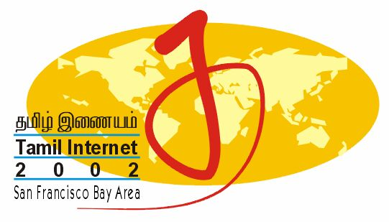

Media Release

Contacts: | Mani M. Manivannan  Tamil Internet 2002  Tel: 1.510.796.2433  TI2002@infitt.org  http://www.infitt.org | A. Narayanan  INFITT  Tel: +(65)-6211-1141  secretariat@infitt.org  http://www.infitt.org

FOR IMMEDIATE RELEASE: 1 May, 2002

California To Host World’s Leading
Tamil Internet Conference in September 2002

Tamil Internet 2002 To Focus On E-Governance, Multimedia Content, The Digital Divide, Entrepreneurship and Technology Standards to serve more than 75 million.

Newark, CA: May 1, 2002 – The world's leading Tamil Internet Conference & Exhibition 2002 (Tamil Internet 2002 ) will be held at the Crowne Plaza Hotel, Foster City, California from September 27 to 29, this year. The decision was announced today by Professor M Anandakrishnan, Chair of the International Forum For Information Technology In Tamil (INFITT), the custodian of the annual international conference. Tamil is one of the major languages of India spoken by over 75 Million people worldwide. Tamil has been a pioneer among Indic languages when it comes to technology implementation and development of digital, multimedia resources and information interchange through internet.

Tamil Internet 2002 is the fifth in the conference series, which began in 1997 in Singapore. The second conference was held in Chennai in 1999, the third in Singapore again in 2000, and the last one in Kuala Lumpur, Malaysia last year.

Centered on the theme ‘Bridging The Digital Divide’, this conference will focus mainly on technical, professional and business issues related to Tamil Internet and Tamil computing. The convention will consist of three components Technical conference, Exhibition and Community events. The technical conference will consist of keynote lectures and technical paper presentations by pioneers in their fields aimed at the specialists and those interested in following key development. Some of the hot topics, which will be discussed at this conference, include Digital Tamil archives, Eradicating Digital Divide, Open Source Development for Tamil, web- and multimedia –assisted learning of Tamil, E-business and E-governance. The conference is expected to draw over 200 delegates from all over the world.

The exhibition will be open to the general public where hardware and software products related to Tamil computing of leading vendors will be displayed with plenty of opportunities for hands-on trials and testing. The exhibition will also feature products in other Indian languages and is expected to draw more than 3000 attendees over three days.

The community event will focus on four specific groups using Tamil language in the United States. There will be facilities for children to learn to use the digital resources to improve their Tamil language skills and the parents will learn to use the online resources to teach Tamil. The youth will learn to use the online resources to learn about their Tamil heritage and contribute their skills to help bridge the digital divide. The elder Tamil Americans will learn to use computers and be able to communicate with other Tamils in Tamil.

“In organizing TI2002, we address the need for handling Tamil related communication in a native way with Tamil scripts, sophisticated application software and information exchange through Internet,” said Professor Anandakrishnan. He added, “this effort helps serve a worldwide Tamil diaspora of over 75 million. Tamil internet and multimedia facilities have accelerated remote and online education, mobile platforms and digital libraries”.
Anandakrishnan noted with gratification the close collaboration of the Center for South Asia Studies and the Chair in Tamil Studies of the University of California, Berkeley that is a co-sponsor of the conference.

Anandakrishnan also announced today the International Organizing Committee (IOC) for Tamil Internet 2002 that includes of some of the leading Tamil software pioneers and educators in the Silicon Valley and around the world:

Chair:
Mr. Mani M. Manivannan, USA (Member, Executive Committee, INFITT)

Deputy Chair:
Dr. Steven M. Poulos, USA (Vice Chairman, Center for South Asia Studies, University of California, Berkeley)

Members:
Prof. M. Anandakrishnan, India (Chair, INFITT)
Mr. Muthu Nedumaran, Malaysia (Vice Chair, INFITT)
Mr. Arun Mahizhnan, Singapore (Executive Director, INFITT)
Dr. K. Kalyanasundaram, Switzerland (Member, Executive Committee, INFITT)
Dr. M. Ponnavaikko, India (Director, Tamil Virtual University)

IOC chair, Mani M Manivannan, a Tamil-American and a founder member of INFITT, said he was especially pleased to have the opportunity to host the conference in US. "California's Silicon Valley is the cradle of the IT civilization in some sense and we the American hosts are very pleased and honored to be able to bring the INFITT family to our home," he added. He also predicted that the Tamil Canadians, who made Tamil such a strong presence on the web among Indic languages, will play a significant role.

IOC vice chair, Dr. Steven M. Poulos, said “to hold the Fifth Tamil Internet Conference in the San Francisco Bay Area is a natural intersection of the early University of California, Berkeley, contribution to the development of the internet; the central position of Silicon Valley in every aspect of hardware and software development over the past decades; the influx of Tamil Americans and other South Asians into this area and their incredible influence and success in the areas of computer engineering and software and hardware development; and finally the position of our Tamil studies program at the University as the most important program for studying Tamil language, literature and culture in North America.”

He hoped that the conference will attract all those interested in the internet -- corporations and individuals, Tamils and non-Tamils, educators and students and other Tamil Americans who are perhaps novices on the net but want to learn more.

About INFITT
The International Forum for Information Technology in Tamil (INFITT) is a not for profit, non-governmental organization that was founded in 2000 to coordinate scattered efforts in Tamil information technology development and promote standards for Tamil IT. Tamil, an ancient language with an unbroken literary tradition of nearly 2000 years, is spoken by over 75 million people worldwide. INFITT’s worldwide individual and institutional members are drawn from the pioneers and leaders of the Tamil internet and computing industry, universities, governments, investors and international organizations. It hosts an annual Tamil Internet conference and provides an international forum to address the issues influencing the evolution of Tamil in internet through its several working groups. For more information about INFITT, please refer to its website at http://www.infitt.org. To contact INFITT, please send email to secretariat@infitt.org

About Center for South Asia Studies at the University of California, Berkeley
Center for South Asia Studies has been instrumental in associating the Tamil American community with the University. The joint project of the community and the Center coming together to endow a Chair in Tamil Studies is unique among all universities in North America. The Tamil studies program at the University is the most important program for studying Tamil language, literature and culture in North America. For more information about the Center for South Asia Studies, please refer to its website at http://www.ias.berkeley.edu/southasia/. To contact CSAS, please send e-mail to csas@uclink.berkeley.edu.

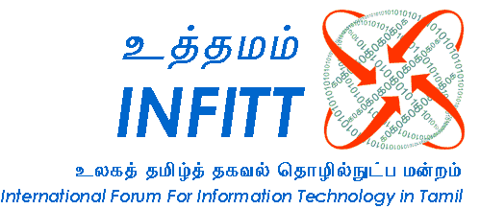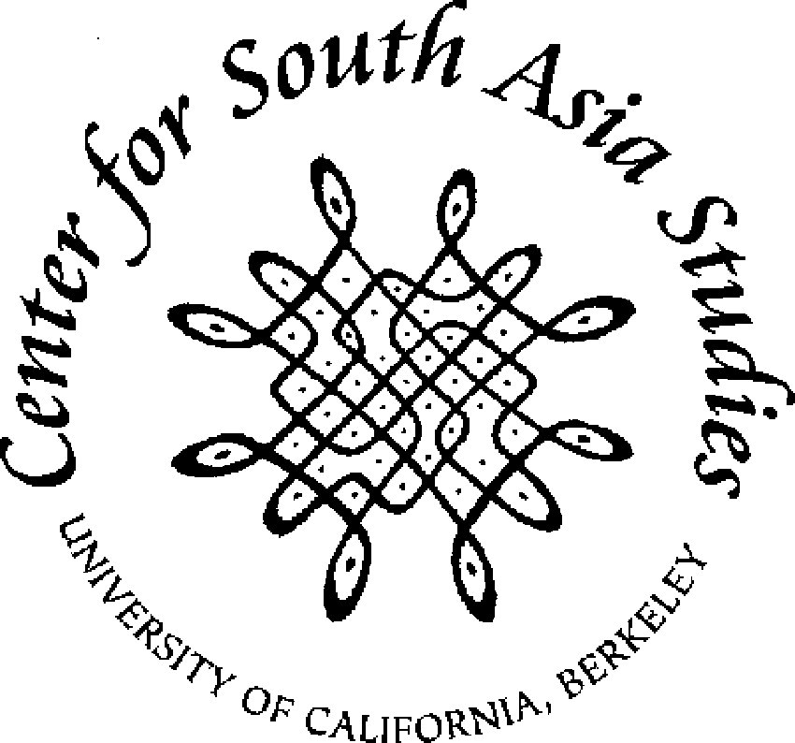

© 2002 by International Forum for Information Technology in Tamil. INFITT, Tamil Internet 2002, INFITT logo design and the Tamil Internet 2002 logo design are trademarks of International Forum for Information Technology. All Rights Reserved.

# # # # # # # # #

